StudentHub Portal
Screenshots / Demo: integrated UI, authentication flow and working project proof
25CS089

1. Integrated UI
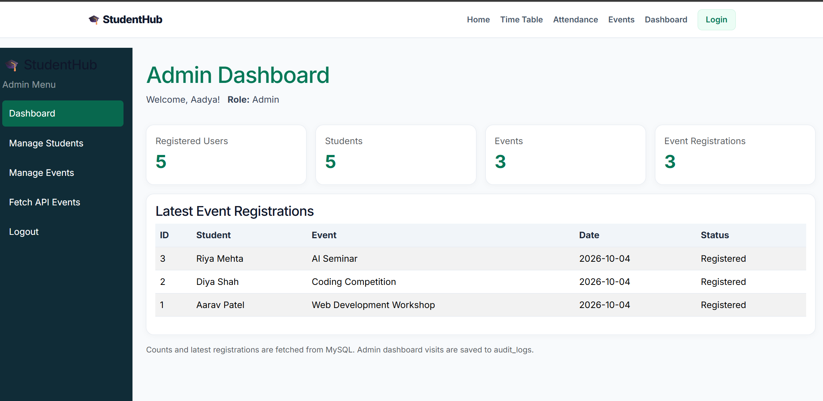
Figure 1: Admin dashboard with sidebar navigation, stats and latest event registrations
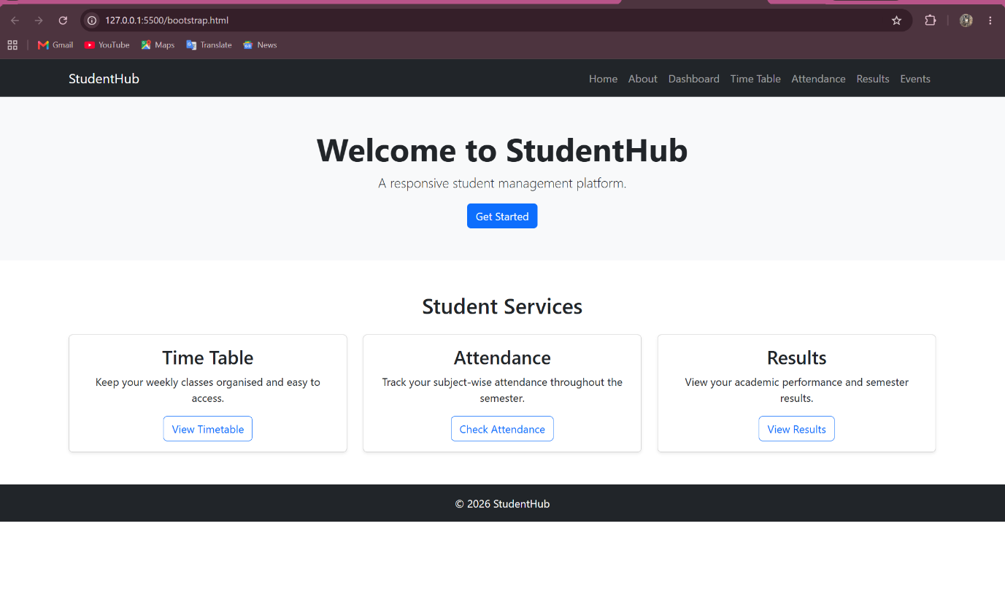
Figure 2: Home page on desktop (Bootstrap responsive layout)
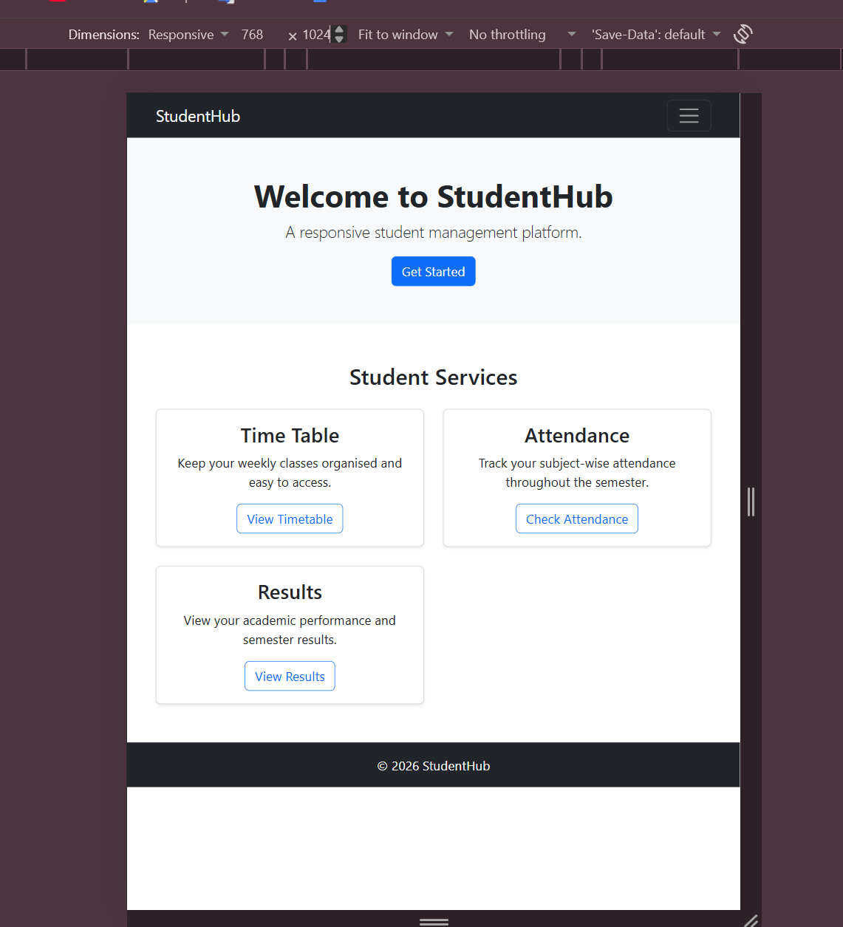
Figure 3: Home page on tablet
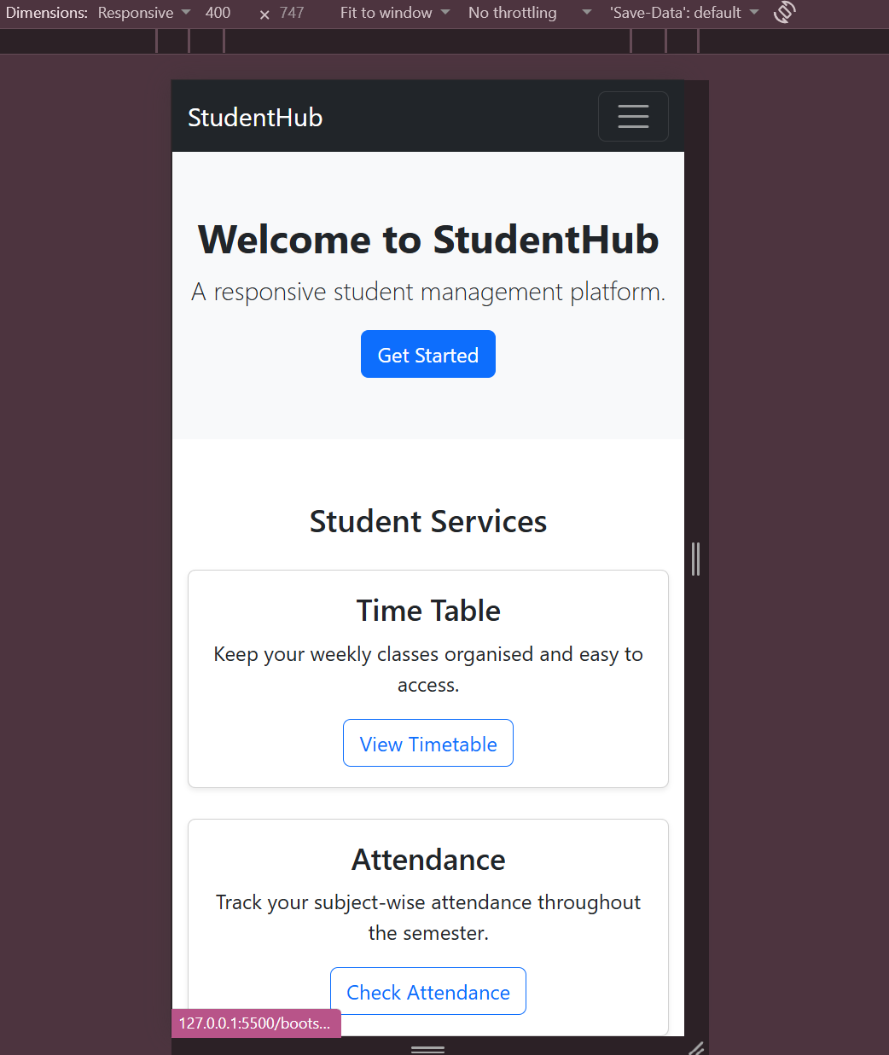
Figure 4: Home page on mobile
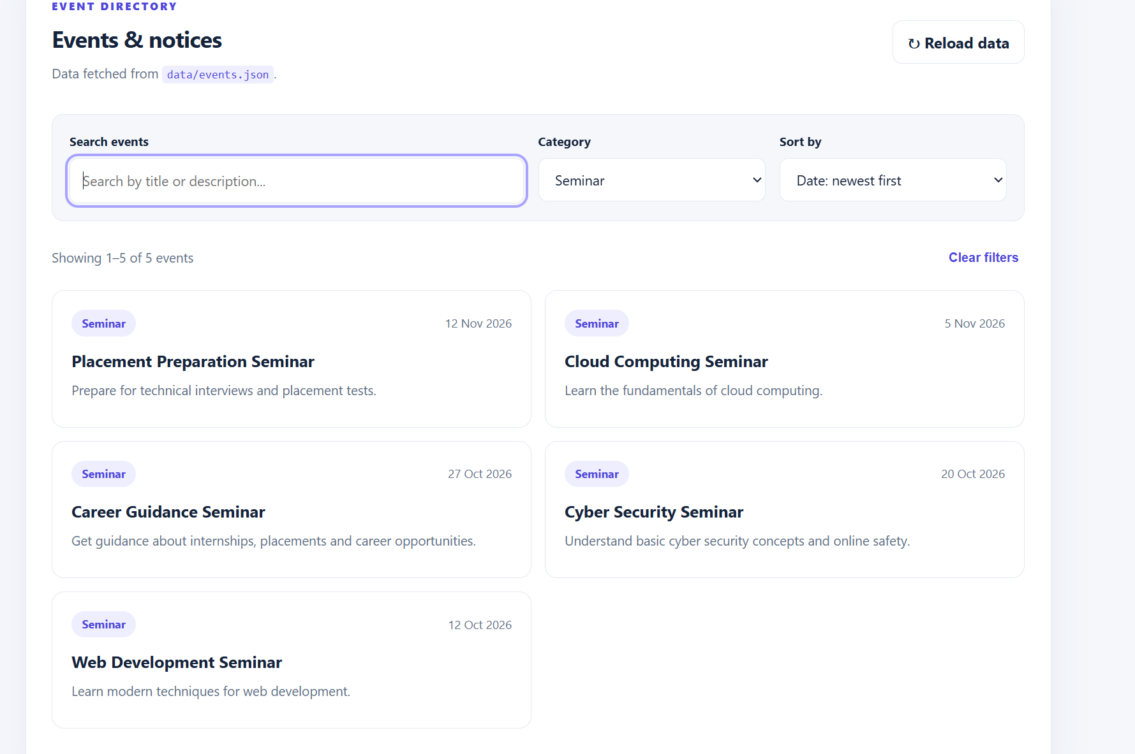
Figure 5: Events page with search, category filter and sort (data loaded via Fetch API)

2. Authentication Flow
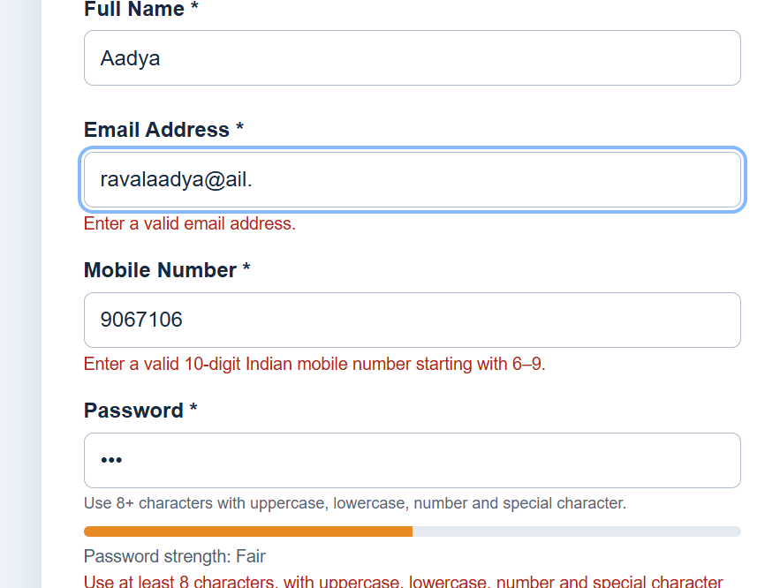
Figure 6: Registration form showing frontend validation errors for invalid email and mobile number
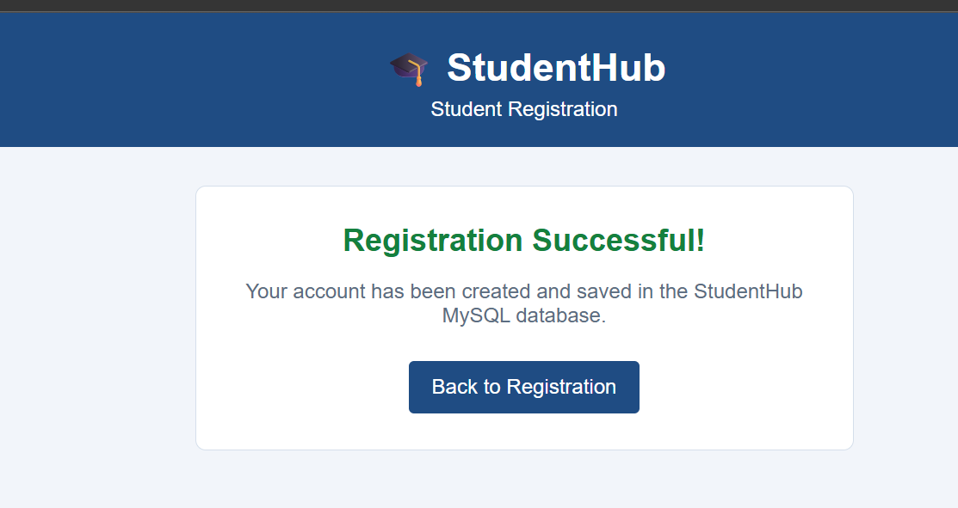
Figure 7: Registration successful, account saved to the MySQL database
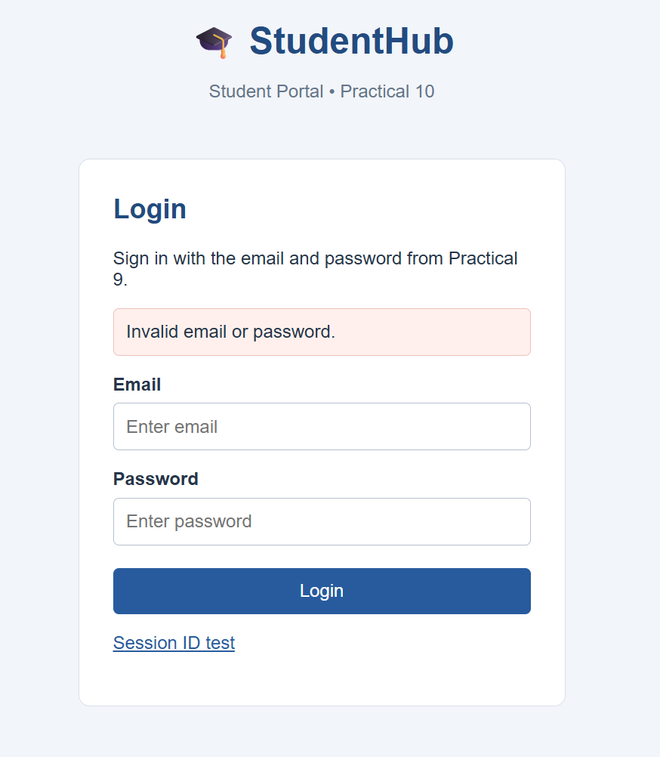
Figure 8: Login rejected with an invalid email or password message
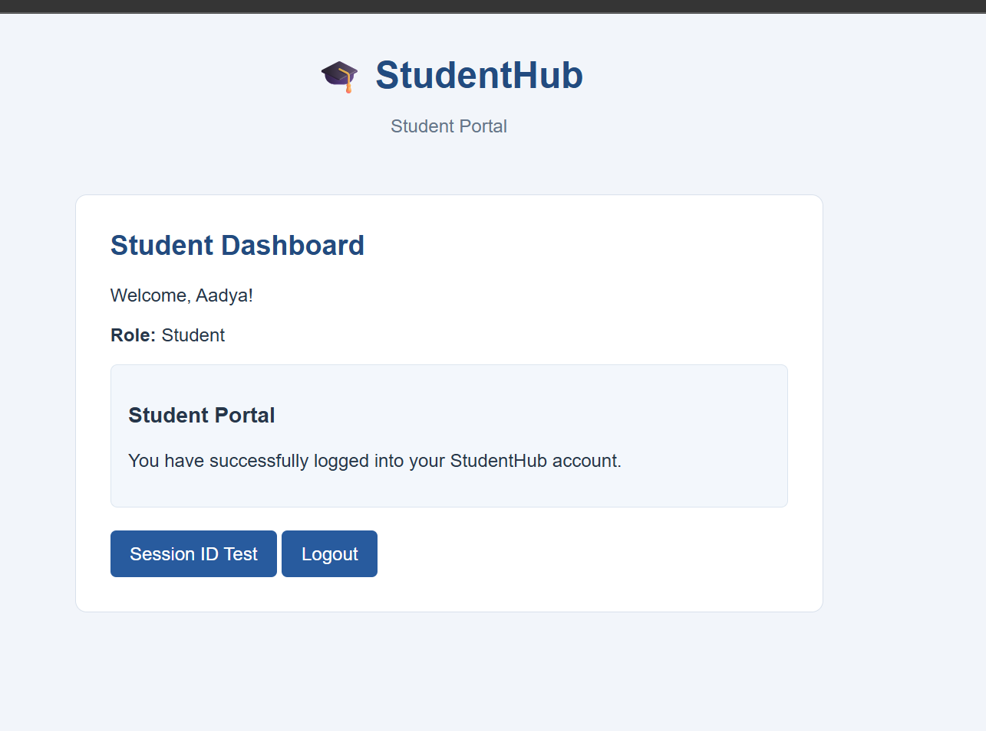
Figure 9: Student logged in and redirected to the Student Dashboard
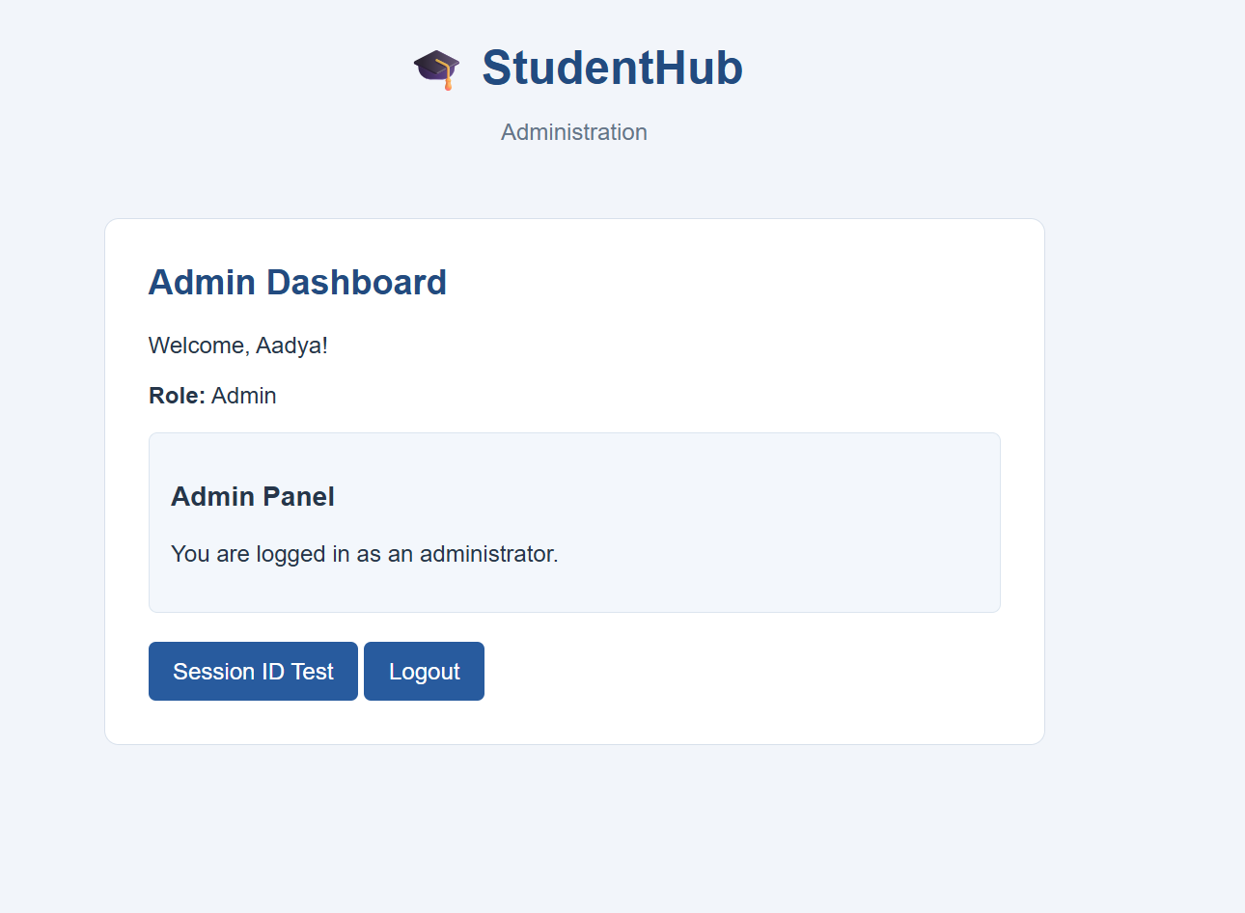
Figure 10: Admin logged in and redirected to the Admin Dashboard
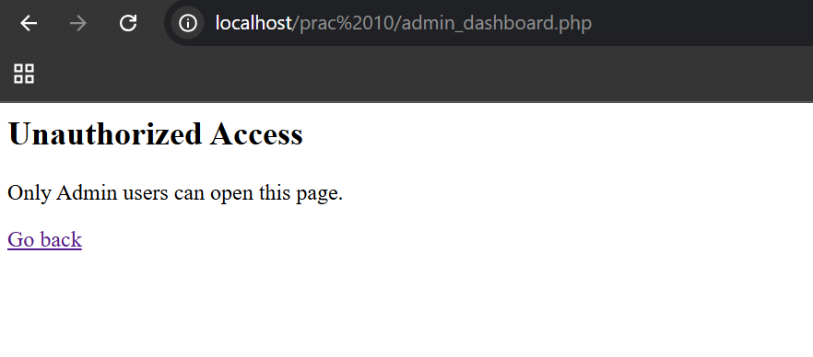
Figure 11: Role-based access: a student blocked from opening the admin dashboard
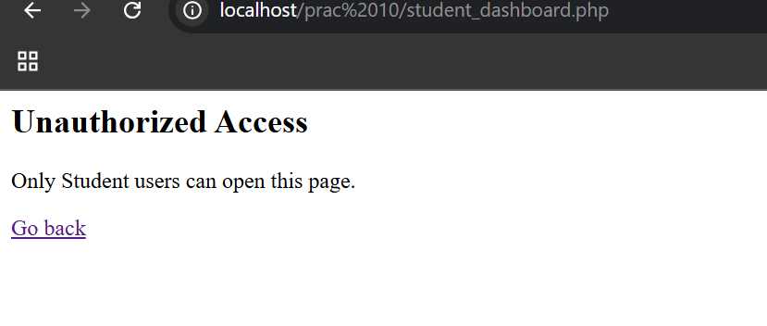
Figure 12: Role-based access: an admin blocked from opening the student dashboard
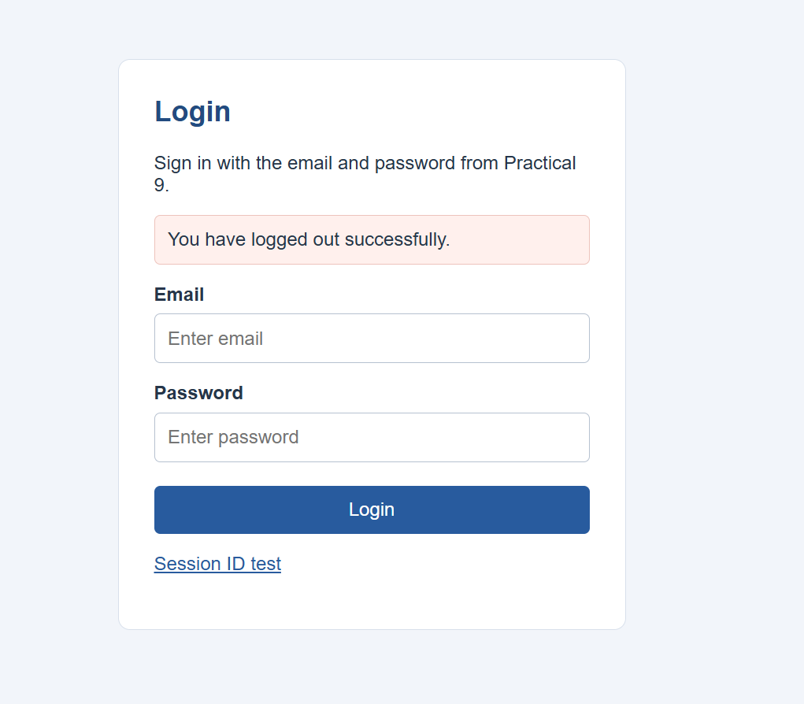
Figure 13: Logout confirmed and user returned to the login page
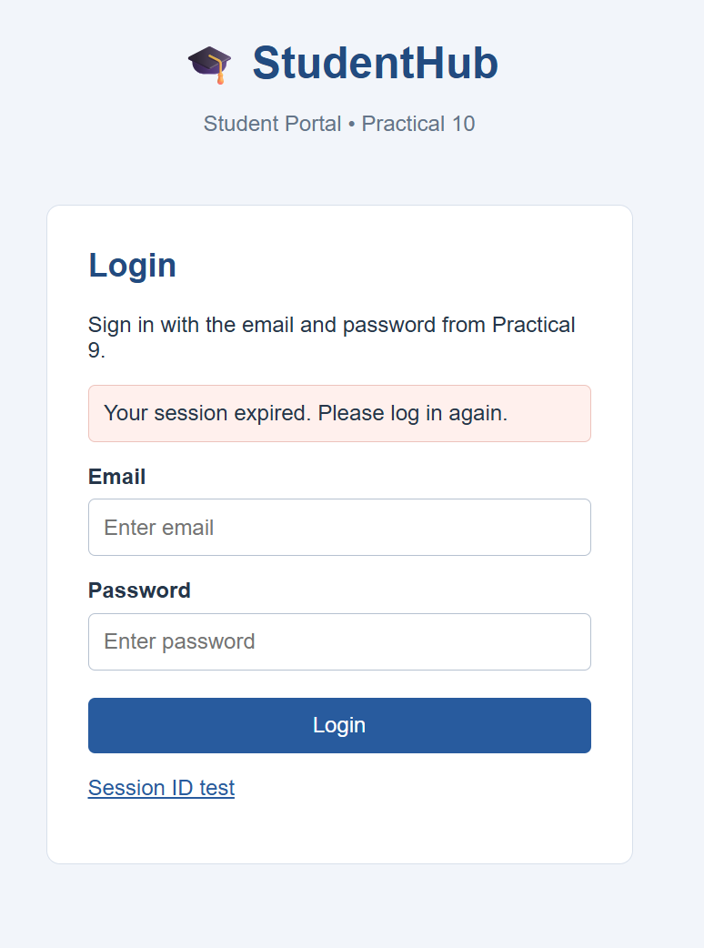
Figure 14: Session timeout: user redirected to login after inactivity

3. Core Features
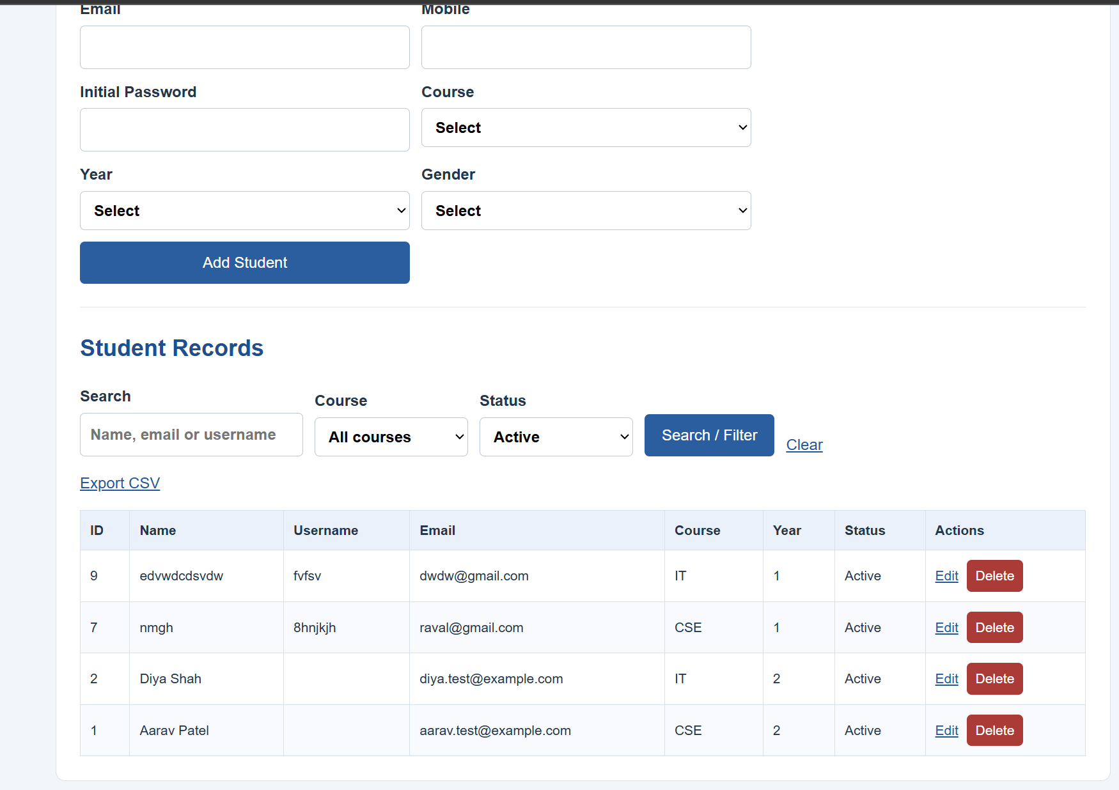
Figure 15: Student management: add student form and student records table
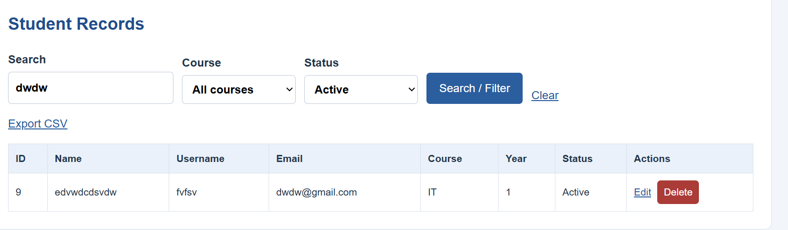
Figure 16: Student search returning matching records
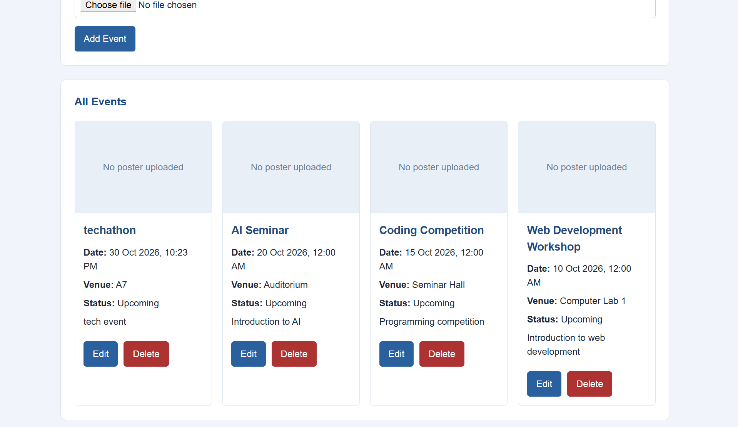
Figure 17: Event management: all events listed with edit and delete actions
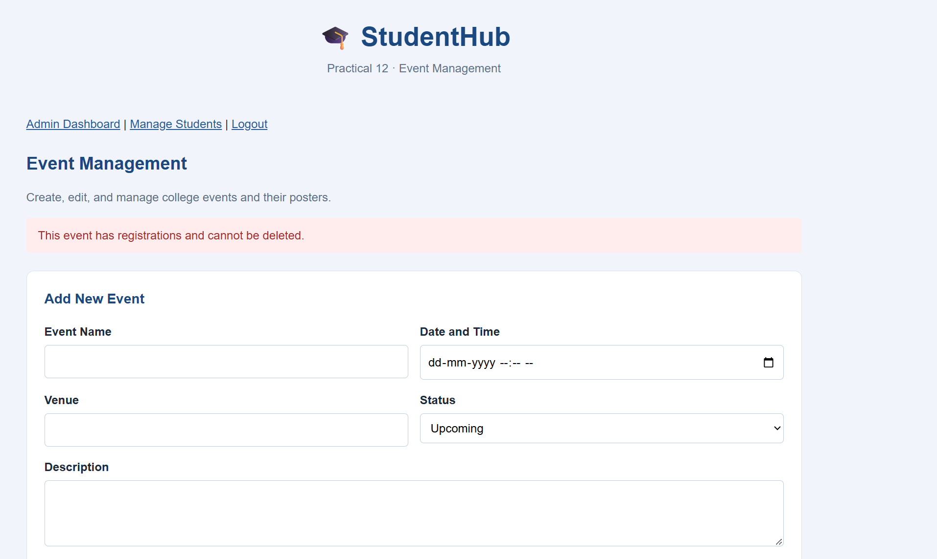
Figure 18: Event with existing registrations is protected from deletion
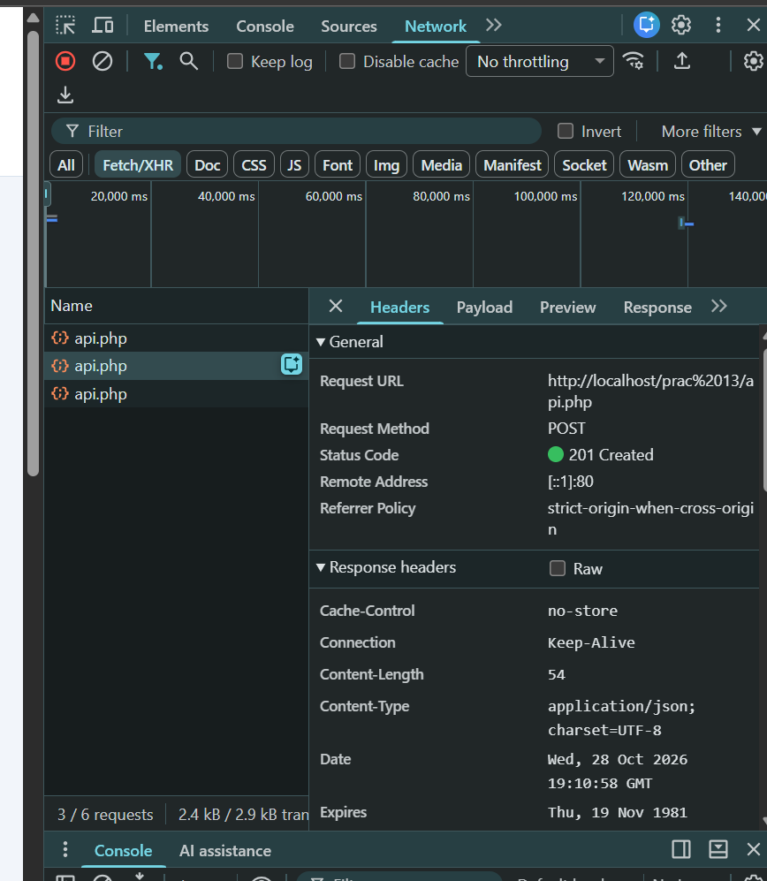
Figure 19: AJAX/Fetch CRUD: POST request to the PHP JSON API returning 201 Created, without page reload

4. Database and Security
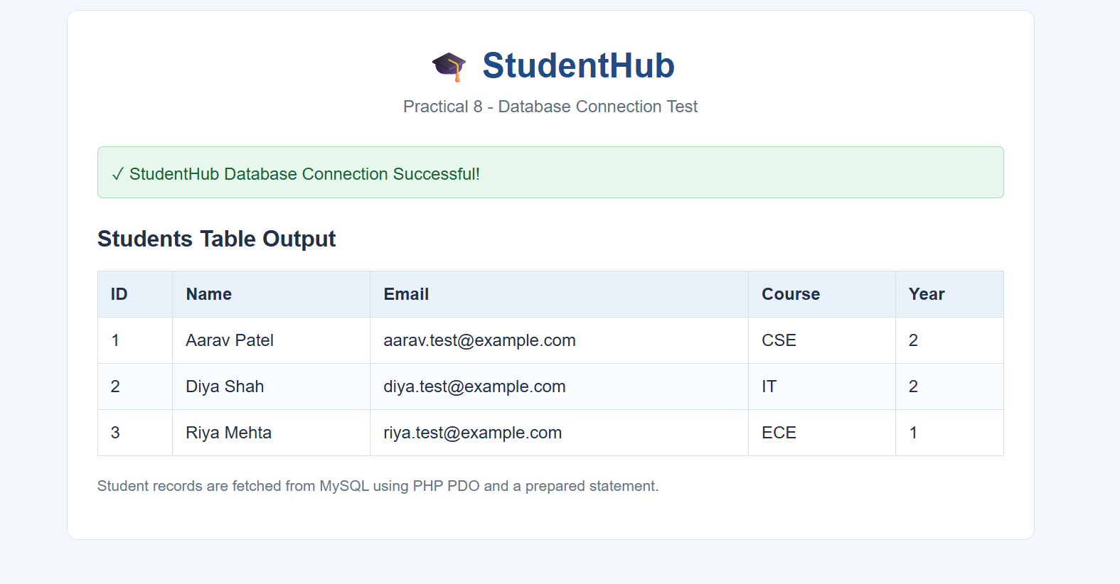
Figure 20: Database connection successful using PHP PDO, with students table output
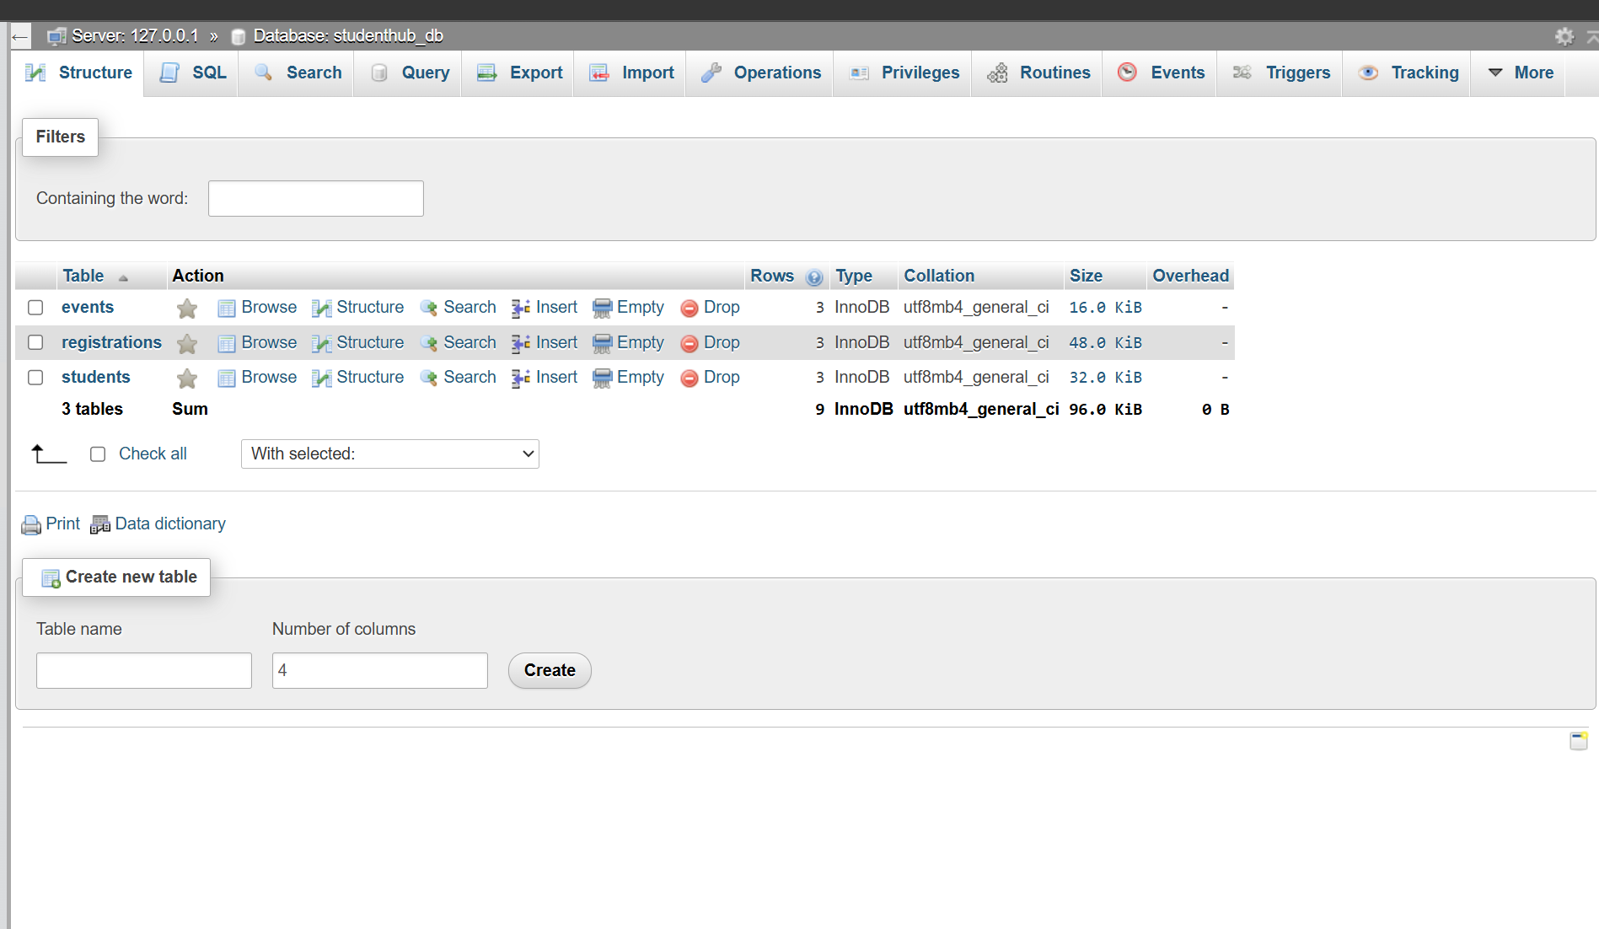
Figure 21: studenthub_db in phpMyAdmin with events, registrations and students tables
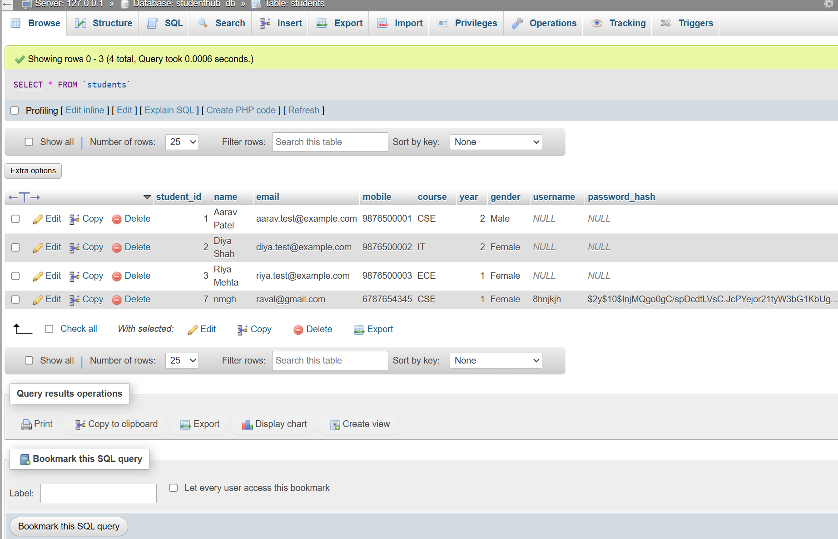
Figure 22: Students table in phpMyAdmin showing passwords stored as hashes
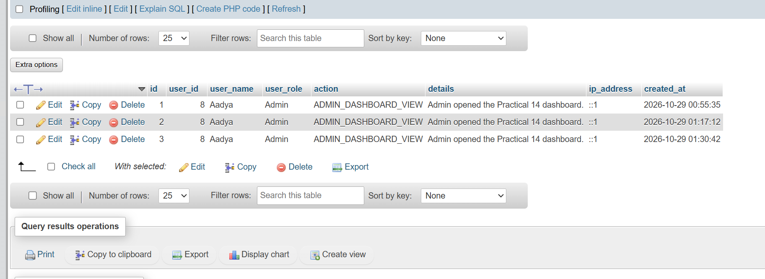
Figure 23: Audit log table recording admin actions

